Learn JavaScript From- https://developer.mozilla.org/en-US/
Node Js official site- https://nodejs.org/en/docs/
NPM (Node Package Manager): https://www.npmjs.com/
ExpressJS official site: https://expressjs.com/

For checking Node version : node –version

Along With the Node comes, NPM(Node Package Manager). By the Help of this node package manager we install,Publish and Manage other Node Programs.
Always use NPM ,do not manually copy paste any modules folder.

Generic steps to install any Package:
STEP 1: a)npm install <package-name> -g //for global installation
b) npm uninstall <package-name> -g
For all global installation modules will install in (C:\Users\Kingshuk\AppData\Roaming\npm\node_modules\)
STEP 2: npm list -g //Lists the packages globally install
STEP 3: npm list -g --depth=0; //For getting the packages installed in (C:\Users\Kingshuk\AppData\Roaming\npm\node_modules\)

Q)what is express?
Ans: Express is a minimal and flexible Node.js web application framework that provides a robust set of features for web and mobile applications.( https://expressjs.com/)

Express application generator
Use the application generator tool, express-generator, to quickly create an application skeleton.
(https://expressjs.com/en/starter/generator.html)

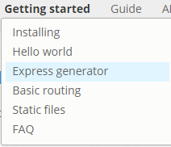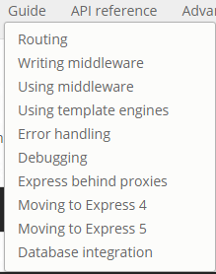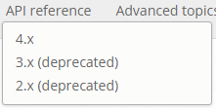
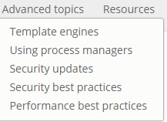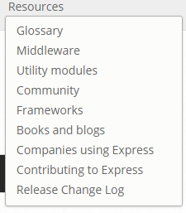

Installing
Assuming you’ve already installed Node.js, create a directory to hold your application, and make that your working directory.
$ mkdir myapp
$ cd myapp
Use the npm init command to create a package.json file for your application. For more information on how package.json works, see Specifics of npm’s package.json handling.
$ npm init
This command prompts you for a number of things, such as the name and version of your application. For now, you can simply hit RETURN to accept the defaults for most of them, with the following exception:
entry point: (index.js)
Enter app.js, or whatever you want the name of the main file to be. If you want it to be index.js, hit RETURN to accept the suggested default file name.
Now install Express in the myapp directory and save it in the dependencies list. For example:
$ npm install express --save
To install Express temporarily and not add it to the dependencies list, omit the –save(-s) option( save option saves the depency in package.js)
$ npm install express

Install express-generator globally with the following command:
$ npm install express-generator -g
Set the path:
Steps:
Installation of express-generator globally: npm install express-generator -g
Set the Path to: C:\Users\Kingshuk\AppData\Roaming\npm
If express command not working

Creating a Express project:
1) express exp_practice_app (For creating a folder cmd)

Basic structure:
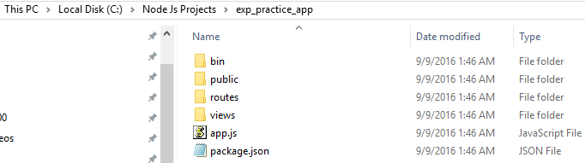
Now we have to costomize it.

bin
node_modules
public
routes
views
app.js | Starting js file
package.json | {  "name": "exp_practice_app",  "version": "0.0.0",  "private": true,  "scripts": {  "start": "node ./bin/www"  },  "dependencies": {  "body-parser": "~1.15.1",  "cookie-parser": "~1.4.3",  "debug": "~2.2.0",  "express": "~4.13.4",  "jade": "~1.11.0", //Default template enjine for node .js  "morgan": "~1.7.0",  "serve-favicon": "~2.3.0"  }  }

2)Go inside the Project directory(C:\Node Js Projects\exp_practice_app), Now run cmd,
npm install (to Download the dependencies which are mentioned in package.json in node_modules after creating the folder)

3)now cmd:
npm start (startin the server)
4)Go to the Browzer and open url(http://localhost:3000/)

You will see basic express will Come up.

For installing any external Package in the node_modules folder
npm install mongodb -S

Q)what is Middleware(https://expressjs.com/en/guide/using-middleware.html)?
Ans: Express is a routing and middleware web framework that has minimal functionality of its own: An Express application is essentially a series of middleware function calls.
Middleware functions are functions that have access to the request object (req), the response object (res), and the next middleware function in the application’s request-response cycle. The next middleware function is commonly denoted by a variable named next.
Middleware functions can perform the following tasks:
- Execute any code.
- Make changes to the request and the response objects.
- End the request-response cycle.
- Call the next middleware function in the stack.
If the current middleware function does not end the request-response cycle, it must call next() to pass control to the next middleware function. Otherwise, the request will be left hanging.
An Express application can use the following types of middleware:
- Application-level middleware
- Router-level middleware
- Error-handling middleware
- Built-in middleware
- Third-party middleware
You can load application-level and router-level middleware with an optional mount path. You can also load a series of middleware functions together, which creates a sub-stack of the middleware system at a mount point.

Basic routing
Routing refers to determining how an application responds to a client request to a particular endpoint, which is a URI (or path) and a specific HTTP request method (GET, POST, and so on).
Each route can have one or more handler functions, which are executed when the route is matched.
Route definition takes the following structure:
app.METHOD(PATH, HANDLER)
Where:
app is an instance of express.
METHOD is an HTTP request method, in lowercase.
PATH is a path on the server.
HANDLER is the function executed when the route is matched.
This tutorial assumes that an instance of express named app is created and the server is running. If you are not familiar with creating an app and starting it, see the Hello world example.
The following examples illustrate defining simple routes.
Respond with Hello World! on the homepage:
app.get('/', function (req, res) {
res.send('Hello World!');
});
Respond to POST request on the root route (/), the application’s home page:
app.post('/', function (req, res) {
res.send('Got a POST request');
});
Respond to a PUT request to the /user route:
app.put('/user', function (req, res) {
res.send('Got a PUT request at /user');
});
Respond to a DELETE request to the /user route:
app.delete('/user', function (req, res) {
res.send('Got a DELETE request at /user');
});
For more details about routing, see the routing guide.

